1------------------------------

string = input()

list = string.split()

print()

res=""

for i in list:

res +=i+" "

print(len(res.split())-1)

print(res.replace("-1",""))

2------------------------------

import math

string = list(map(float,input().split()))

num=string.index(0)

print(num)

for i in range(num-1,-1,-1):

print(round(float(math.sqrt(string[i])),5))

3------------------------------

n=str(input())

k=len(n)

res=0

for i in range(k):

if n[i]=='A':

res+=1

print(res)

4------------------------------

str = input()

uniq = []

for i in str:

if i not in uniq:

uniq.append(i)

print(len(uniq))

for i in uniq:

print(i, str.count(i))

5------------------------------

num = int(input())

flag = False

if num == 1:

print("NO")

elif num > 1:

for i in range(2, num):

if (num % i) == 0:

flag = True

break

if flag:

print("NO")

else:

print("YES")

6------------------------------

n=int(input())

for i in range(0,n):

for j in range(0,n):

print(i+j, end=' ')

print()

7------------------------------

n = int(input())

for i in range(n):

if i == n:

for j in range(n):

print(1, end=' ')

elif i % 2 != 0:

print(1, end=' ')

for j in range(n - 2):

print(0, end=' ')

print(1, end=' ')

else:

for j in range(n):

print(1, end=' ')

8------------------------------

def Fibonacci(n):

if n<=1:

return n

else:

return(Fibonacci(n-1) + Fibonacci(n-2))

n=int(input())

n=n+1

for i in range(n):

print(Fibonacci(i))

9------------------------------

def Calc(list):

if not list:

return []

return [list[-1]] + Calc(list[:-1])

n=int(input())

list=input().split()

for i in range(n):

list[i] = int(list[i])

print(str(Calc(list)).replace("[","").replace("]","").replace(",",""))

10-----------------------------

import math

def Log2(x):

if x == 0:

return false

return (math.log10(x) /

math.log10(2))

def isPowerOfTwo(n):

return (math.ceil(Log2(n)) ==

math.floor(Log2(n)))

n=int(input())

if(isPowerOfTwo(n)):

print("YES")

else:

print("NO")

11-----------------------------

import turtle

pen = turtle.Turtle()

pen.color('blue')

pen.shape('turtle')

pen.pensize(2)

pen.speed(5)

pen.left(180)

pen.circle(60)

pen.forward(150)

pen.circle(60)

pen.up()

pen.forward(10)

pen.down()

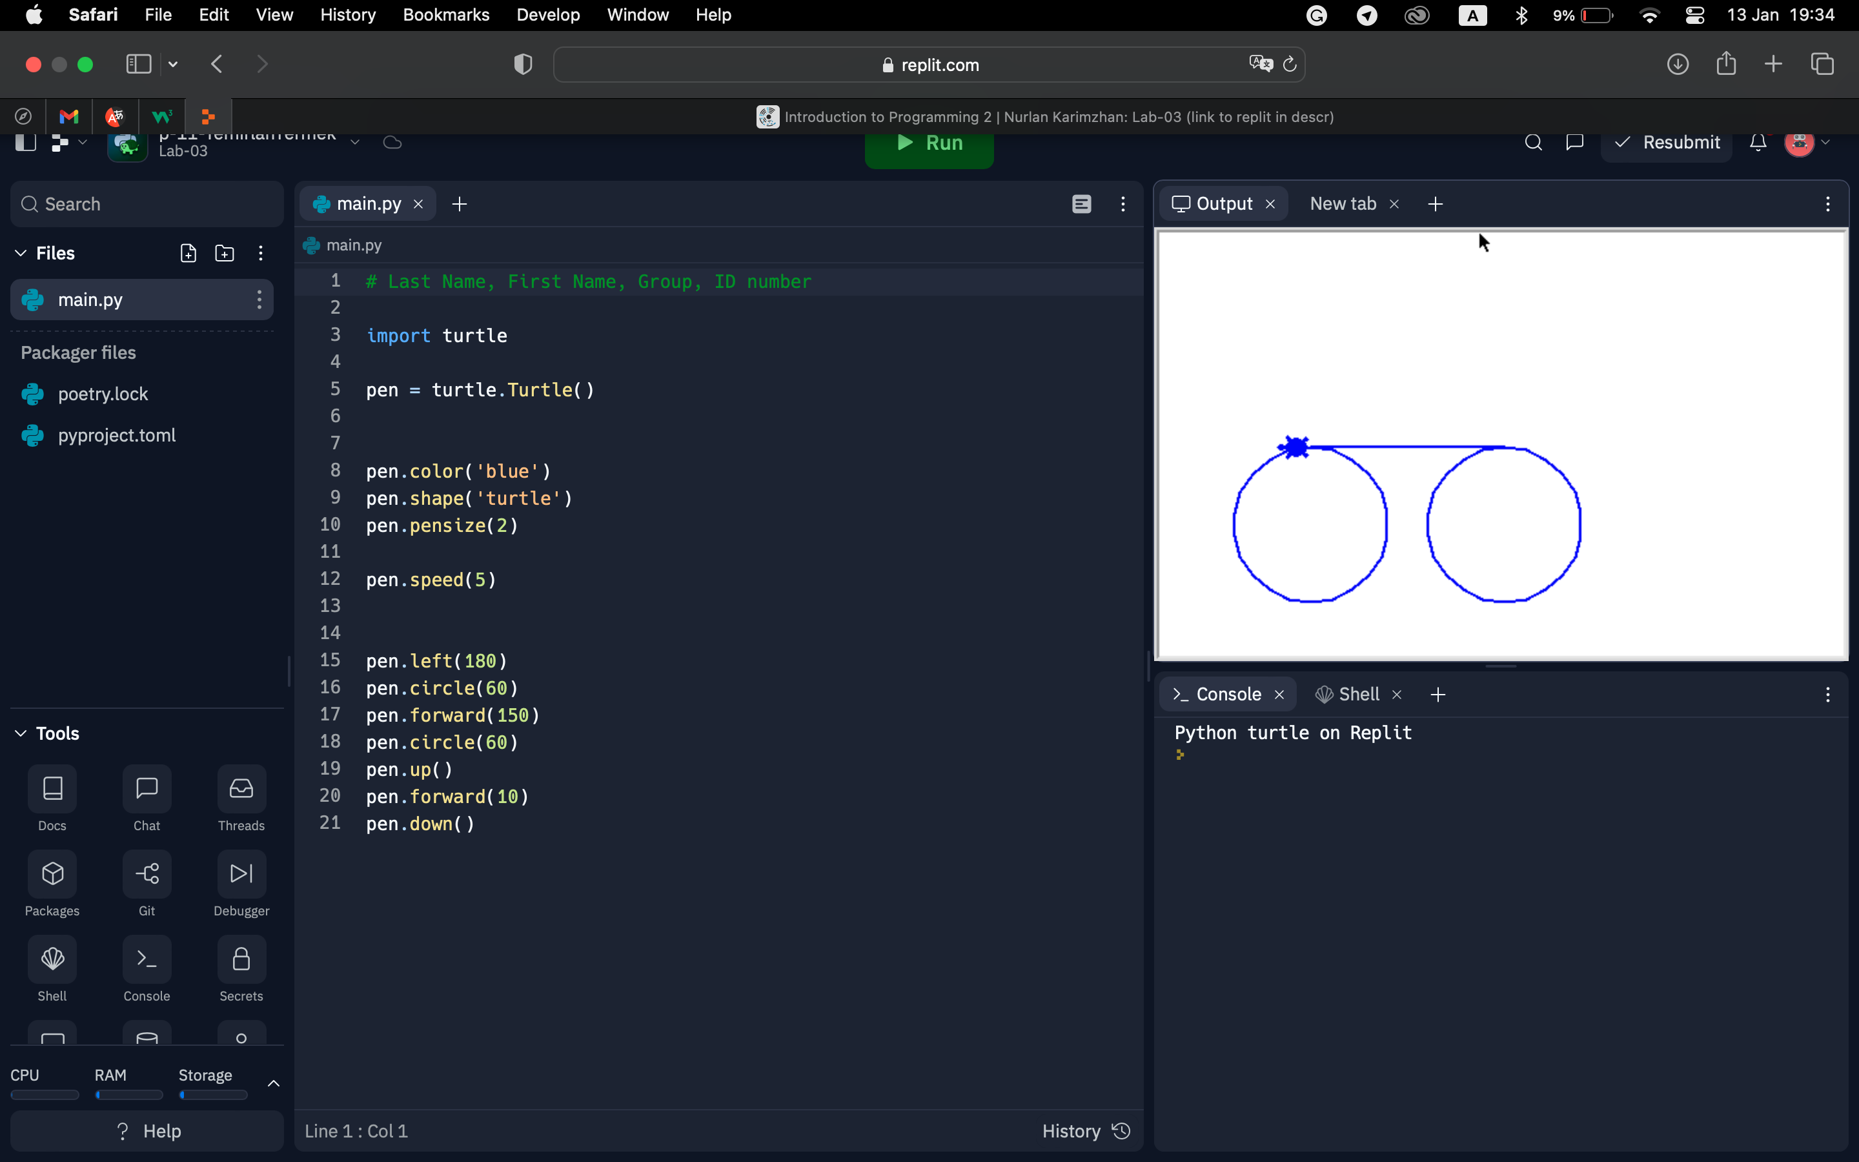

12-----------------------------

import turtle as t

t.speed(0.5)

t.hideturtle()

angle=150

side=100

pointies = 8

rotate = 360/pointies

angle_left=angle

angle_right=angle

t.color("red","red")

t.begin_fill()

for p in range(pointies):

t.forward(side)

t.right(angle_right)

t.forward(side)

t.left(angle_left)

t.right(rotate)

t.end_fill()

13-----------------------------

import turtle

t = turtle.Turtle()

t.color('blue')

t.hideturtle()

t.fillcolor('blue')

t.begin_fill()

t.penup()

t.goto(-75,150)

t.pendown()

t.circle(10)

t.end_fill()

t.begin_fill()

t.penup()

t.goto(75,150)

t.pendown()

t.circle(10)

t.end_fill()

t.penup()

t.goto(0,0)

t.pendown()

t.circle(100,90)

t.penup()

t.setheading(180)

t.goto(0,0)

t.pendown()

t.circle(-100,90)

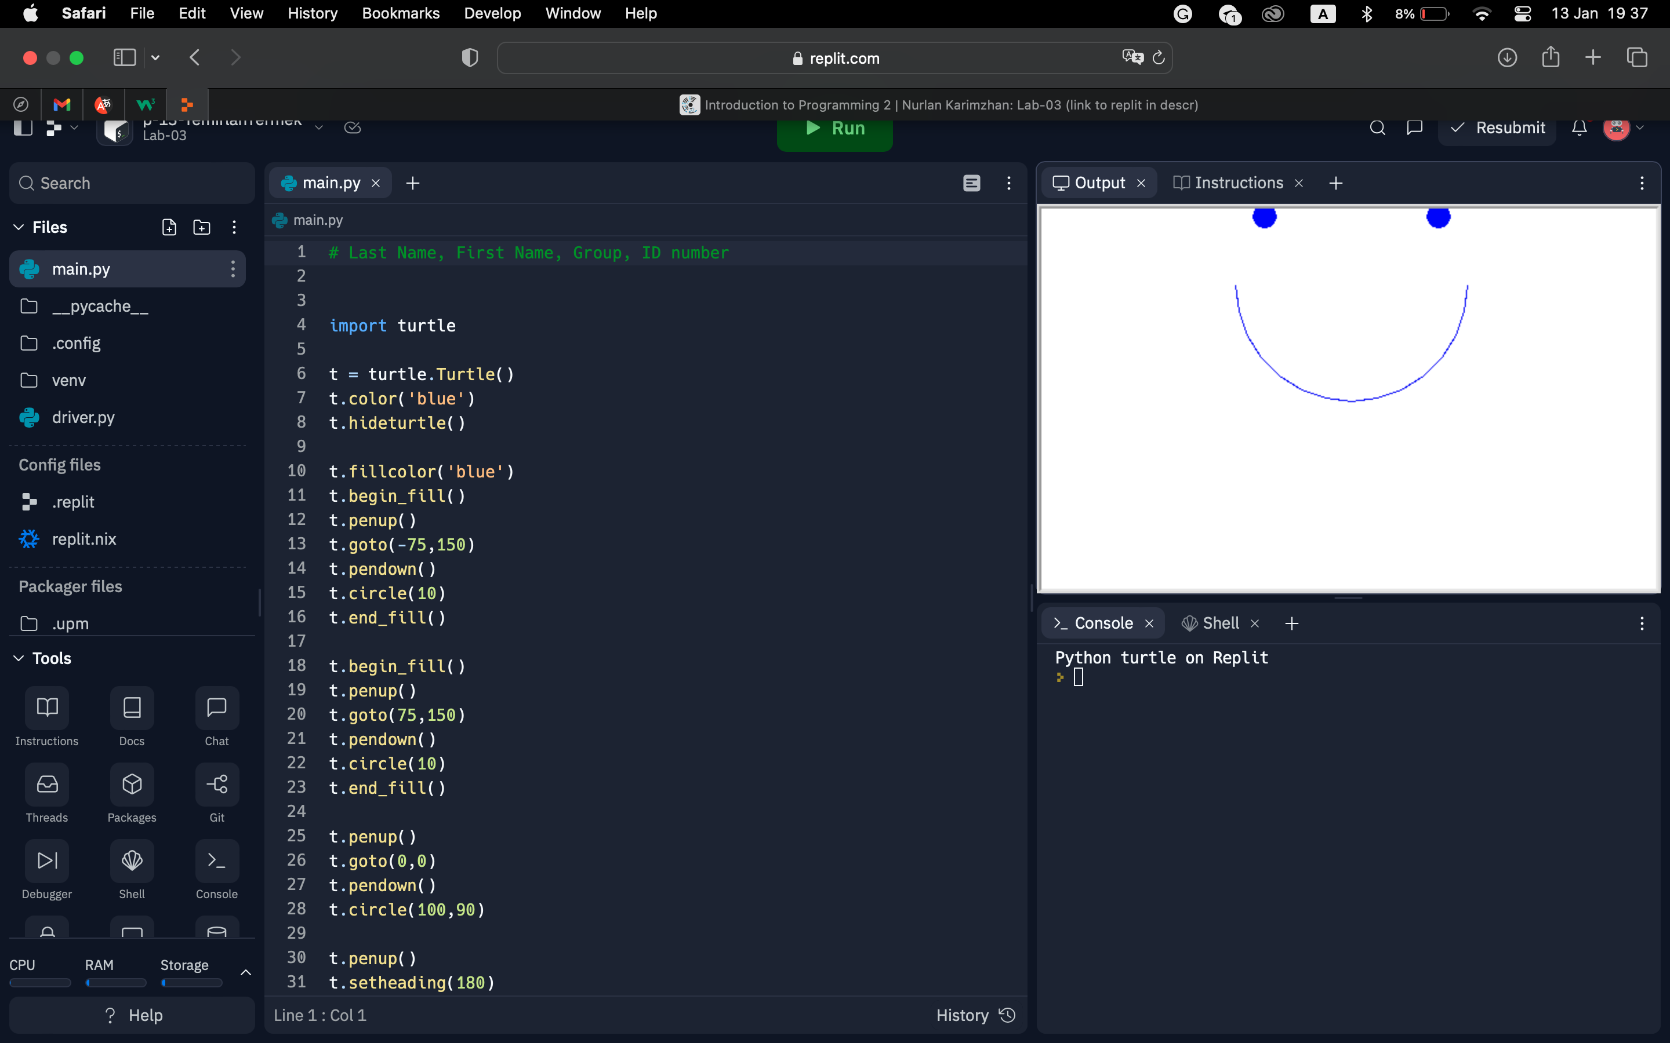

14-----------------------------

import turtle

colors = ['red', 'purple', 'blue', 'green', 'orange', 'yellow','tomato','grey']

t = turtle.Pen()

t.speed(20)

turtle.bgcolor('black')

for x in range(142):

t.pencolor(colors[x%8])

t.width(x//100 + 1)

t.forward(x)

t.left(45)

15-----------------------------

import turtle

t = turtle.Turtle()

t.hideturtle()

t.shape('turtle')

t.pensize(2)

t.speed(9)

t.color('blue')

t.right(135)

t.forward(75)

t.right(90)

t.forward(75)

t.left(135)

t.forward(106)

t.left(135)

t.forward(75)

t.right(90)

t.forward(75)

t.right(135)

t.forward(106)

t.left(135)

t.forward(75)

t.left(90)

t.forward(75)

t.left(45)

t.forward(106)

t.left(90)

t.forward(106)

t.right(135)

t.forward(75)

t.right(90)

t.forward(75)

